WISE TECH INDIA PITCHATHON 2025
ANDHRA & TELANGANA EDITION
EVENT OUTCOME & STARTUP IMPACT REPORT | 9 AUGUST 2025
ORGANISERS  WISE Tech | SPJIMR + Vignan TBI | PITCH DAY  9 August 2025 | STARTUPS RECOGNISED  3 prize winners + 2 consolation awards

1. Event Overview
The WISE Tech India Pitchathon 2025 – Andhra & Telangana Edition was organised by WISE Tech | SPJIMR in collaboration with Vignan Technology Business Incubator (Vignan TBI) at Vignan TBI, Guntur. The programme created a platform for early-stage startups to present their ideas, demonstrate their solutions and engage with an entrepreneurship ecosystem focused on innovation, business development and growth.
The event brought founders together for a focused pitching experience, exposure to expert perspectives and recognition of promising ventures. The edition celebrated entrepreneurial effort across different sectors and highlighted the role of incubation partnerships in helping startups gain visibility and access to wider opportunities.

2. Objectives and Programme Focus
- Provide early-stage startups with a platform to pitch their business ideas and solutions.
- Encourage founders to communicate their value proposition, market opportunity and impact clearly.
- Connect startups with mentors, evaluators and the broader WISE Tech | SPJIMR ecosystem.
- Recognise promising ventures through awards and create a pathway towards the WISE Tech India Pitchathon Grand Finale.
- Increase visibility for innovative businesses emerging from Andhra Pradesh and Telangana.

3. Award-Winning Startups
AWARD | STARTUP | RECOGNITION
1st Prize | Kode Blue Technologies | Recognised as the first-prize winner of the Andhra & Telangana Edition.
2nd Prize | SriGPAvens Life Sciences Pvt. Ltd. | Recognised for its pitch and startup proposition.
3rd Prize | Dadspire Solutions (Freshpod India) | Awarded third prize in the regional edition.
Consolation Prize | Eunoia Innovations | Recognised for its participation and pitch.
Consolation Prize | Neem Toys | Recognised for its purpose-led venture focused on natural wooden toys.

4. Key Event Outcomes
OUTCOME AREA | RESULT / SIGNIFICANCE
Startup visibility | Participating ventures presented their solutions before an entrepreneurship-focused audience and gained recognition for their work.
Founder pitching experience | The programme offered founders an opportunity to refine how they explain their problem, solution, value proposition and growth potential.
Recognition and motivation | Three startups received first, second and third prizes, while two startups received consolation awards.
Pathway to national exposure | The pitchathon communication highlighted an opportunity for winners to progress to the WISE Tech India Pitchathon Grand Finale, with a chance to compete for prizes worth ₹5 lakh.
Incubation partnership | The collaboration between SPJIMR WISE Tech and Vignan TBI strengthened connections between regional startups and a wider innovation ecosystem.
Mentor and jury engagement | The event benefited from the contributions of jury members Santosh Kumar and Sandeep Satheesan, whose perspectives added value to the pitching experience.

5. Neem Toys: A Purpose-Led Startup Story
Neem Toys received a consolation prize at the regional pitchathon. The venture focuses on natural wooden toys made from neem wood, with a mission that links product design to community impact. Its story highlights the potential of natural-material products and sustainable craftsmanship to create livelihood opportunities for rural women and young people.
Neem Toys’ subsequent participation in the SPJIMR WISE Tech Pitchathon semi-finals in Mumbai on 14 November 2025, where the startup reported reaching the top 35 from more than 600 participants across India, illustrates how a regional platform can become one step in a startup’s wider entrepreneurial journey. The achievement reflects the value of communicating both the product proposition and the social purpose behind the venture.
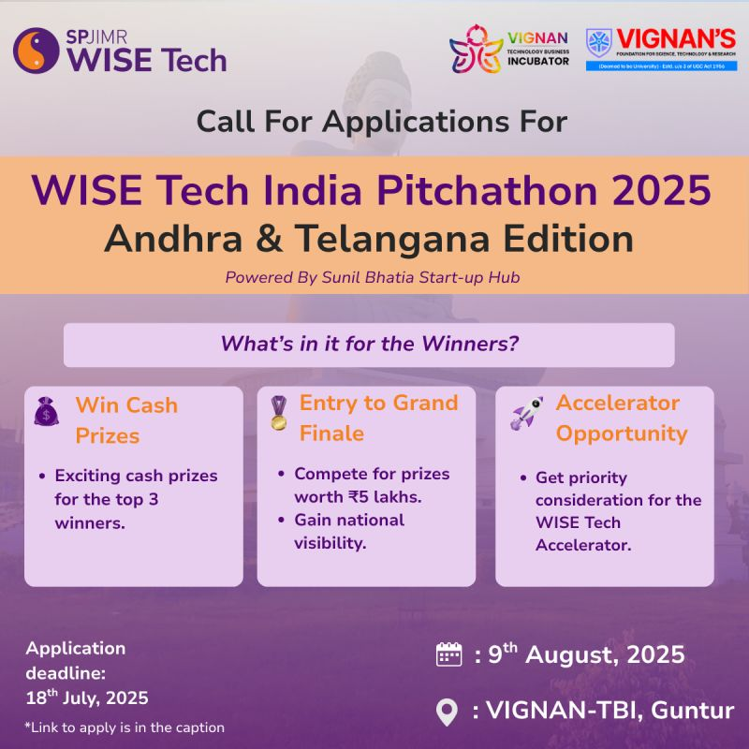
Neem Toys was among the consolation-prize recipients at the 2025 regional edition.

6. Event Highlights in Pictures
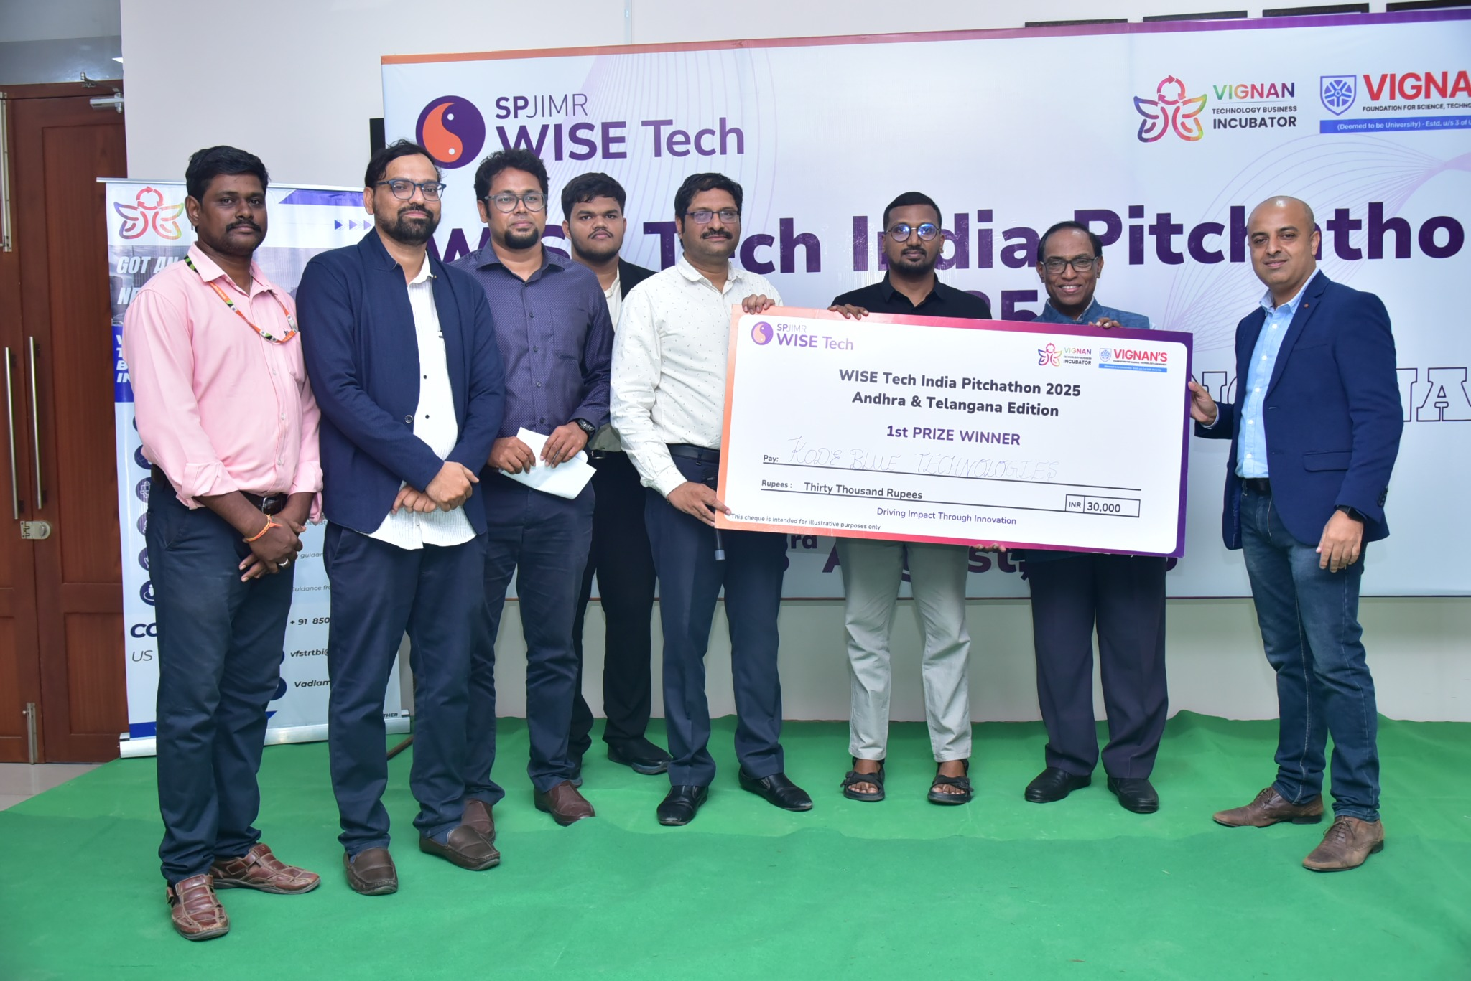
First-prize presentation to Kode Blue Technologies.
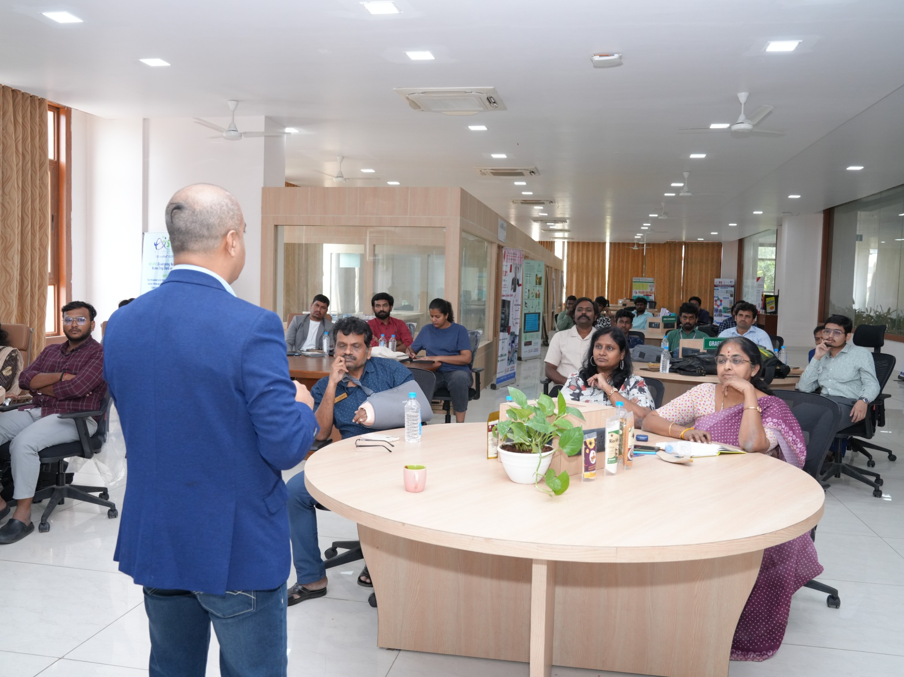
Startup ecosystem interaction and discussion during the event.
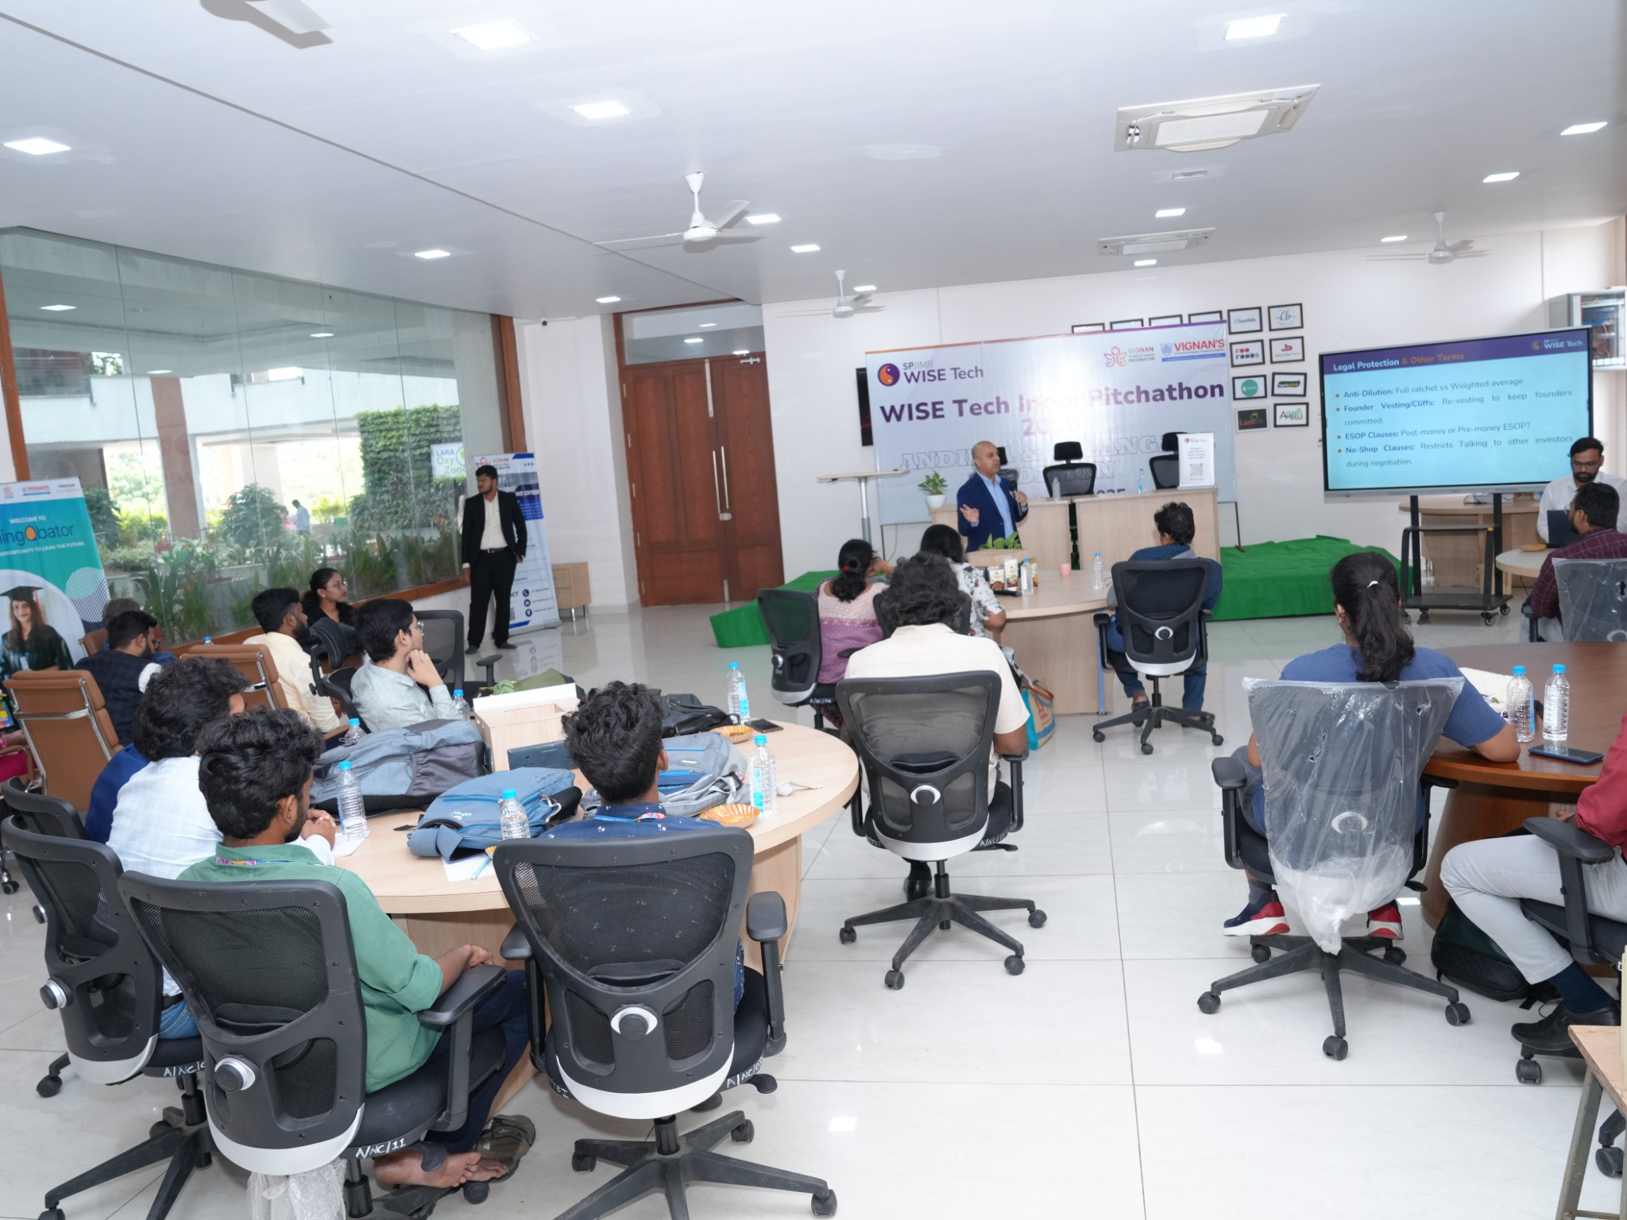
Pitchathon session and participant engagement.
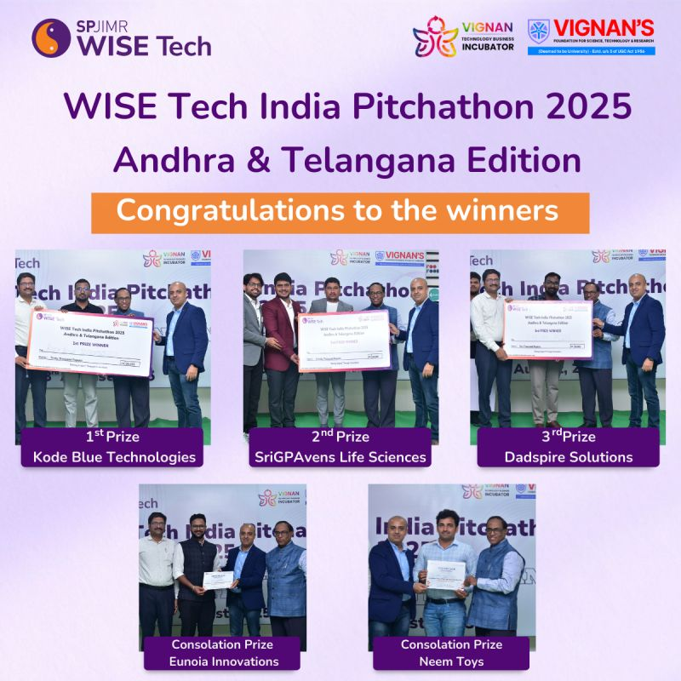
Award winners of the WISE Tech India Pitchathon 2025 – Andhra & Telangana Edition.

7. Acknowledgement
Vignan TBI acknowledges WISE Tech | SPJIMR for the collaboration and the opportunity to bring a national startup platform to the region. Appreciation is extended to the participating founders, jury members, mentors, organisers and audience whose engagement contributed to the programme. The event reflects the importance of sustained partnerships in strengthening startup development and entrepreneurial learning.

8. Conclusion
The WISE Tech India Pitchathon 2025 – Andhra & Telangana Edition served as a meaningful platform for startup pitching, recognition and ecosystem engagement. With three prize winners and two consolation-prize recipients, the event celebrated founder initiative and brought regional ventures into contact with broader entrepreneurship opportunities. For Vignan TBI, the collaboration demonstrated the value of connecting startups with structured pitching platforms, experienced ecosystem contributors and pathways for future growth.
VIGNAN TBI • CONNECTING STARTUPS • CELEBRATING INNOVATION • ENABLING GROWTH

